**Project Idea and Proposal**

In this generation, we have many food options to choose from for our diets, including fast food, which is a highly popular choice for many people's lunches and dinners. One of the largest fast-food chains in the world is McDonald's, which offers a wide variety of foods in their restaurants, such as burgers, chicken nuggets, fries, and soft drinks. Given the vast amount of data they need to manage, it is likely that McDonald's uses an Oracle database to store and organise their records. That is the reason why our group has chosen to focus on this company for our topic.

To create a well-organised database for the company, we need to identify the various operations that take place in their stores and divide them into different fields. For example, McDonald's may have separate teams for fried food, burgers, and drinks, with each team led by a manager who manages many employees working on their respective tasks.

To reflect these different data categories, we could create several tables in Oracle to store the relevant information. One table could be called "employees," which would store data about managers and employees. Another table could be named "foods" to store data on food items, price, calories, and the employees responsible for preparing them. Similarly, we could create a "drinks" table to store data on beverage items, price, employees, and calories. Finally, may create an “order” table to hold the data about orders. Consequently, it would be easier to read and manipulate the information as needed.

## **Database Design - Normalizaition**

**UNF**

Payments-Customers [ paymentId, payDate, payAmount (cusNumer, cusFirstName, cusLastName, cusPhone)]

Orders-Customers [ orderNumber, orderDate, orderStatus, (cusNumer, cusFirstName, cusLastName, cusPhone)]

Orders-Foods-Employees [ orderNumber, orderDate, orderStatus, (foodId, foodName, price, calories, (employeeID, emFirstName, emLastName, emPhone, department, jobTitle))]

Orders-Drinks-Employees [ orderNumber, orderDate, orderStatus, (drinkId, drinkName, price, calories, (employeeID, emFirstName, emLastName, emPhone, department, jobTitle))]

**1NF**

Payments [ paymentId, cusNumber, payDate, payAmount ]

Payments -Customers [ cusNumber, paymentId, cusFirstName, cusLastName, cusPhone ]

Orders [ orderNumber, orderDate, orderStatus ]

Orders-Customers [ cusNumer, orderNumber, cusFirstName, cusLastName, cusPhone ]

Orders-Foods [ orderNumber, orderDate, orderStatus ]

Foods [ foodId, orderNumber, foodName, price, calories ]

Employees-Foods [ employeeID, foodId, emFirstName, emLastName, emPhone, department, jobTitle ]

Orders-Drinks [ orderNumber, orderDate, orderStatus ]

Drinks [ drinkId, orderNumber, drinkName, price, calories ]

Employees-Drinks [ employeeID, drinkId, emFirstName, emLastName, emPhone, department, jobTitle ]

**2NF**

Payments [ paymentId, cusNumber, payDate, payAmount ]

Payments-Customers [ cusNumber, paymentId ]

Payments-Customers2NF [ cusNumber, cusFirstName, cusLastName, cusPhone ]

Orders [ orderNumber, orderDate, orderStatus ]

Orders-Customers [ cusNumer, orderNumber]

Orders-Customers2NF [ cusNumer, cusFirstName, cusLastName, cusPhone ]

Orders-Foods [ orderNumber, orderDate, orderStatus ]

Foods [ foodId, orderNumber]

Foods2NF [ foodId, foodName, price, calories ]

Employees-Foods [ employeeID, foodId]

Employees-Foods2NF [ employeeID, emFirstName, emLastName, emPhone, department, jobTitle ]

Orders-Drinks [ orderNumber, orderDate, orderStatus ]

Drinks [ drinkId, orderNumber]

Drinks2NF [ drinkId, drinkName, price, calories ]

Employees-Drinks [ employeeID, drinkId]

Employees-Drinks2NF [ employeeID, emFirstName, emLastName, emPhone, department, jobTitle ]

**3NF**

Payments [ paymentId, cusNumber, payDate, payAmount ]

Payments-Customers [ cusNumber, paymentId, cusFirstName, cusLastName, cusPhone ]

Payments-Customer2NF [ cusNumber, cusFirstName, cusLastName, cusPhone ]

Orders [ orderNumber, orderDate, orderStatus ]

Orders-Customers [ cusNumer, orderNumber]

Orders-Customers2NF [ cusNumer, cusFirstName, cusLastName, cusPhone ]

Orders-Foods [ orderNumber, orderDate, orderStatus ]

Foods [ foodId, orderNumber]

Foods2NF [ foodId, foodName, price, calories ]

Employees-Foods [ employeeID, foodId]

Employees-Foods2NF [ employeeID, emFirstName, emLastName, emPhone, department(FK)]

Employees-Foods3NF [ department, jobTitle ]

Orders-Drinks [ orderNumber, orderDate, orderStatus ]

Drinks [ drinkId, orderNumber]

Drinks2NF [ drinkId, drinkName, price, calories ]

Employees-Drinks [ employeeID, drinkId]

Employees-Drinks2NF [ employeeID, emFirstName, emLastName, emPhone, department(FK) ]

Employees-Drinks3NF [department, jobTitle ]

**Merging Relations**

Payments [ paymentId, cusNumber, payDate, payAmount ]

Payments-Customers [ cusNumber, paymentId, cusFirstName, cusLastName, cusPhone ]

Payments-Customers2NF [ cusNumber, cusFirstName, cusLastName, cusPhone ]

Orders [ orderNumber, orderDate, orderStatus ]

Orders-Customers [ cusNumer, orderNumber]

~~Orders-Customers2NF [ cusNumer, cusFirstName, cusLastName, cusPhone ]~~

~~Orders-Foods [ orderNumber, orderDate, orderStatus ]~~

Foods [ foodId, orderNumber]

Foods2NF [ foodId, foodName, price, calories ]

Employees-Foods [ employeeID, foodId]

Employees-Foods2NF [ employeeID, emFirstName, emLastName, emPhone, department(FK)]

Employees-Foods3NF [ department, jobTitle ]

~~Orders-Drinks [ orderNumber, orderDate, orderStatus ]~~

Drinks [ drinkId, orderNumber]

Drinks2NF [ drinkId, drinkName, price, calories ]

Employees-Drinks [ employeeID, drinkId]

~~Employees-Drinks2NF [ employeeID, emFirstName, emLastName, emPhone, department(FK) ]~~

~~Employees-Drinks3NF [department, jobTitle ]~~

## **Entity Relationship Diagram (ERD)**

## 

**Data Dictionary**

TABLE1: PAYMENTS

|  |  |  |  |  |  |  |  |  |
| --- | --- | --- | --- | --- | --- | --- | --- | --- |
| **Column** | **Data Type** | **Size, Precision** | **Default** | **PK/FK** | **Required** | **Range** | **Sample Data** | **Notes** |
| paymentId | NUMBER | 4 |  | PK | Y | 1-9999 | 1234 |  |
| cusNumer | NUMBER | 4 |  | FK | Y | 1-9999 | 1234 |  |
| payDate | DATE |  |  |  | Y |  | 19-OCT-04 |  |
| payAmount | NUMBER | 10,2 |  |  | Y |  | 66.78 |  |

TABLE2: ORDERS

|  |  |  |  |  |  |  |  |  |
| --- | --- | --- | --- | --- | --- | --- | --- | --- |
| **Column** | **Data Type** | **Size, Precision** | **Default** | **PK/FK** | **Required** | **Range** | **Sample Data** | **Notes** |
| orderNumber | VARCHAR2 | 5 |  | PK | Y |  | O1234 |  |
| orderDate | DATE |  |  |  | Y |  | 19-OCT-04 |  |
| orderStatus | VARCHAR2 | 25 |  |  | Y |  | preparing |  |
| cusNumber | NUMBER | 4 |  | FK | Y | 1-9999 | 2526 |  |
| itemId | VARCHAR2 | 5 |  | FK | Y |  | A1234 |  |

TABLE3: CUSTOMERS

|  |  |  |  |  |  |  |  |  |
| --- | --- | --- | --- | --- | --- | --- | --- | --- |
| **Column** | **Data Type** | **Size, Precision** | **Default** | **PK/FK** | **Required** | **Range** | **Sample Data** | **Notes** |
| cusNumber | NUMBER | 4 |  | PK | Y | 1-9999 | 1234 |  |
| cusFirstName | VARCHAR2 | 25 |  |  | Y |  | “sujung” |  |
| cusLastName | VARCHAR2 | 25 |  |  | Y |  | “song” |  |
| cusPhone | VARCHAR2 | 10 |  |  | Y |  | 6475348686 | Assuming North American phone number |

TABLE4: FOODS

|  |  |  |  |  |  |  |  |  |
| --- | --- | --- | --- | --- | --- | --- | --- | --- |
| **Column** | **Data Type** | **Size, Precision** | **Default** | **PK/FK** | **Required** | **Range** | **Sample Data** | **Notes** |
| foodId | VARCHAR2 | 5 |  | PK | Y |  | F1234 |  |
| foodName | VARCHAR2 | 50 |  |  | Y |  | cheeseburger |  |
| price | NUMBER | 9,2 |  |  | Y |  | 19.99 |  |
| calories | NUMBER | 4 |  |  | Y | 1-1999 | 232 |  |
| respEmployeeID | NUMBER | 4 |  | FK | Y |  | 1234 |  |

TABLE5: DRINKS

|  |  |  |  |  |  |  |  |  |
| --- | --- | --- | --- | --- | --- | --- | --- | --- |
| **Column** | **Data Type** | **Size, Precision** | **Default** | **PK/FK** | **Required** | **Range** | **Sample Data** | **Notes** |
| drinkId | VARCHAR2 | 5 |  | PK | Y |  | D2281 |  |
| drinkName | VARCHAR2 | 35 |  |  | Y |  | coke |  |
| price | NUMBER | 9,2 |  |  | Y |  | 5.99 |  |
| calories | NUMBER | 3 |  |  | Y | 1-999 | 158 |  |
| respEmployeeID | NUMBER | 4 |  | FK | Y |  | 1234 |  |

TABLE6: EMPLOYEES

|  |  |  |  |  |  |  |  |  |
| --- | --- | --- | --- | --- | --- | --- | --- | --- |
| **Column** | **Data Type** | **Size, Precision** | **Default** | **PK/FK** | **Required** | **Range** | **Sample Data** | **Notes** |
| employeeID | NUMBER | 4 |  | PK | Y | 1-9999 | 1234 | Autonumbered identity |
| cusFirstName | VARCHAR2 | 25 |  |  | Y |  | “sujung” |  |
| cusLastName | VARCHAR2 | 25 |  |  | Y |  | “song” |  |
| cusPhone | VARCHAR2 | 10 |  |  | Y |  | 6475348686 | Assuming North American phone number |
| department | VARCHAR2 | 25 |  |  | Y |  | ‘Front Counter’ |  |
| jobTitle | VARCHAR2 | 25 |  |  | Y |  | ‘Crew Member’ |  |

## Database Scripting and Creation, (Business Reports)

User View 1 – cusOrder. This is part of the order view for the customers. This database is very important, as it contains the details of customer orders. Businesses can use this information to promote items or consider removing items that sell less. Additionally, the order status can be checked to determine the order processing stage.

**Customer Orders Reports**

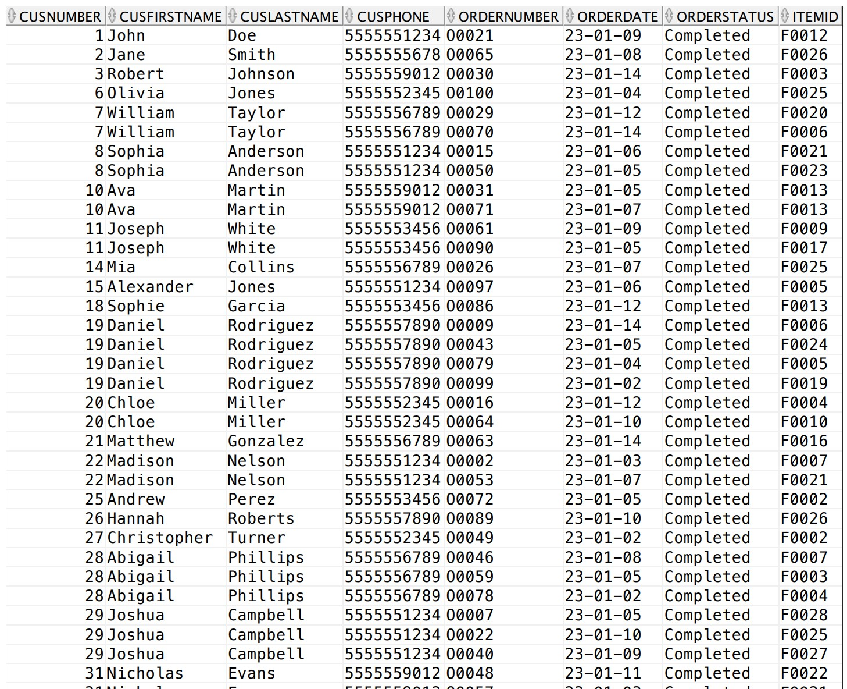

User View 2 – cusPayment, This is the payment view, which illustrates the payment situation in the store. The company can consider providing discounts to customers who frequently purchase products, which can help maintain good client relations. Additionally, the dates can help the business manage the supply of foods and drinks by identifying the days when more items need to be produced.

**Customer Payments Reports**

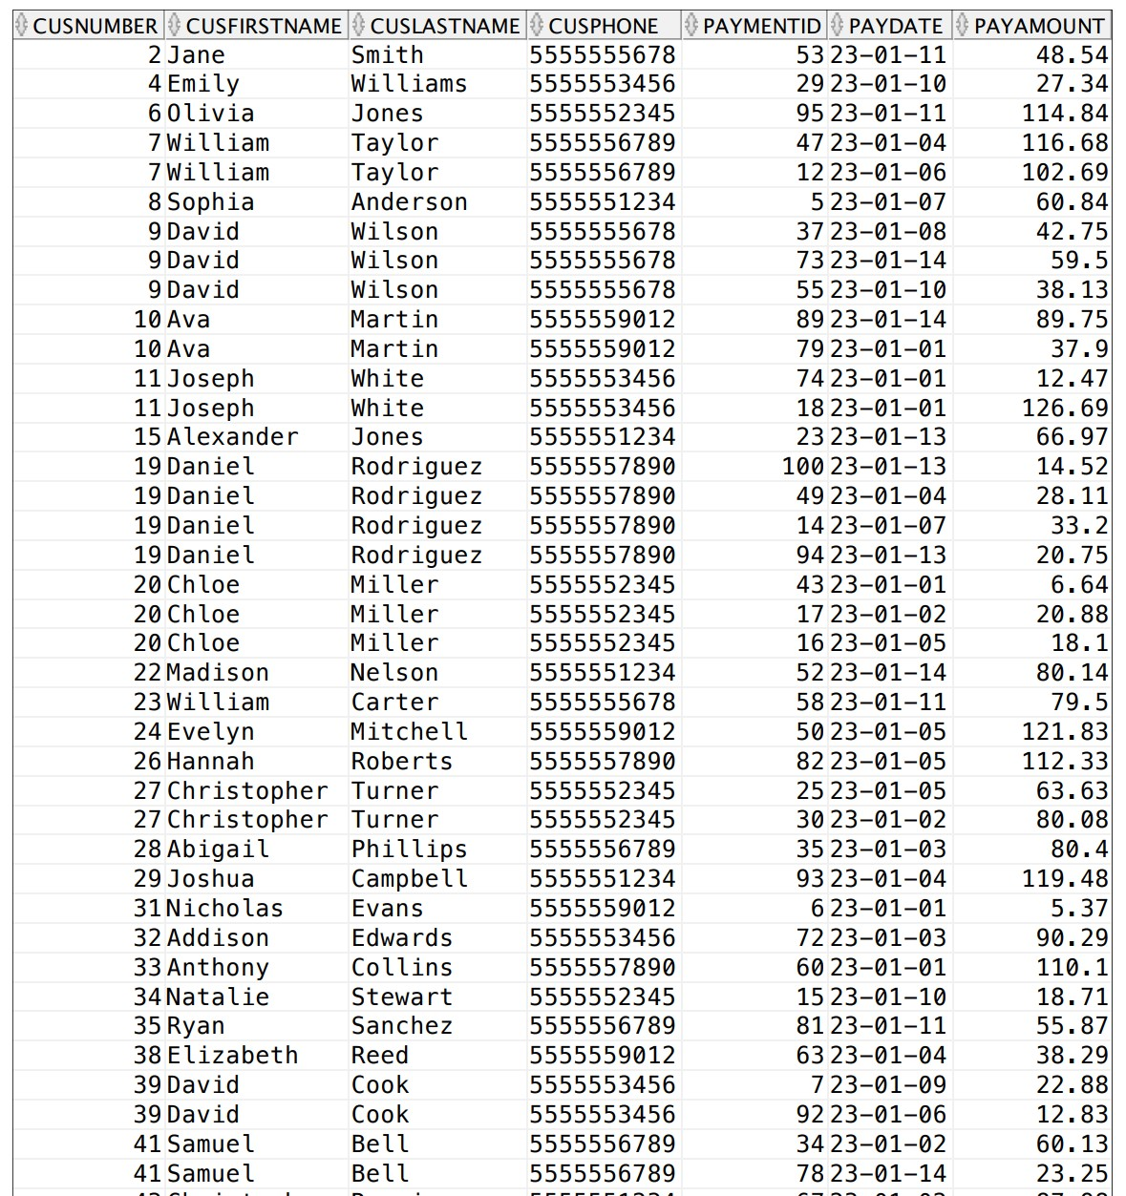

User View 3 – foodOrders, The foodOrders view is used to show order details, including the items ordered by the customer and the calorie count of each food item. This feature is especially helpful for people looking for low-calorie options. Additionally, the company can manage the types of food offered to design different diets for customers.

**Food Orders Reports**

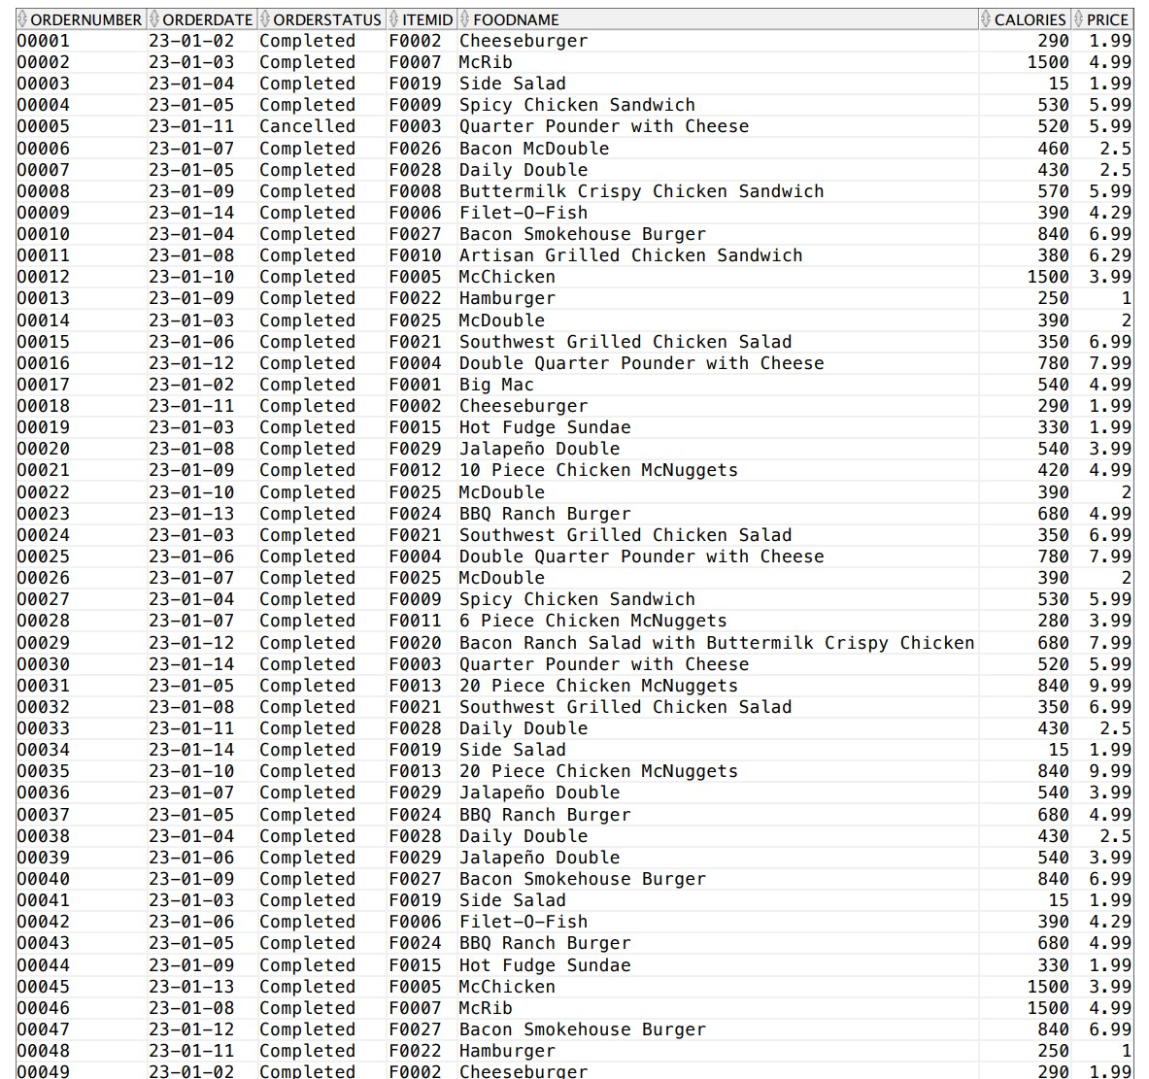

User View 4 – mcEmploy, The mcEmploy view displays employee details, making it easier to manage job duties. With this view, managers can see which employees are available to take on new assignments or which employees may be handling too much work. Additionally, the view allows for easy manipulation of different teams.

**Employee Reports**

|  |  |  |  |  |
| --- | --- | --- | --- | --- |
| **Department:** Drive-Thru |  |  |  |  |
| **JobTitle** | **employee ID** | **Name** | **Phone** | **Handling** |
| Cashier | 9923 | Chloe Davis | 5555557890 | McDouble |
| 6502 | Isabella White | 5555553456 | 6 Piece Chicken |
| 7042 | Sophie Garcia | 5555552345 | McNuggets |
| Drive-Thru Manager | 2333 | William Gonzalez | 5555556789 | McFlurry with OREO Cookies |
| 5968 | Olivia Lopez | 5555553456 | - |
| Drive-Thru Order Taker | 4038 | Noah Johnson | 5555555678 | Hamburger |
| Drive-Thru Team Member | 6782 | William Smith | 5555555678 | Cheeseburger |
| 1256 | William Hernandez | 5555551234 | Daily Double |
| Drive-Thru Team Trainer | 3425 | Avery Wilson | 5555559012 | Bacon Ranch Salad with Buttermilk |
| 2471 | David Wilson | 5555552345 | Crispy Chicken |
| Order Taker | 7903 | Daniel Gonzalez | 5555556789 | Cinnamon Melts |
| 7104 | Hannah Jones | 5555559012 | Buttermilk Crispy Chicken Sandwich |
| 3199 | Madison Anderson | 5555551234 | - |
| Shift Manager | 8917 | Daniel Davis | 5555557890 | McChicken |

|  |  |  |  |  |
| --- | --- | --- | --- | --- |
| **Department:** Front Counter |  |  |  |  |
| **JobTitle** | **employee ID** | **Name** | **Phone** | **Handling** |
| Cashier | 3666 | Madison Martinez | 5555551234 | - |
| 5274 | Joshua Taylor | 5555556789 | McRib |
| Crew Member | 3948 | Olivia Garcia | 5555551234 | Big Mac |
| 9152 | Isabella Davi | 5555553456 | - |
| 1397 | Avery Smith | 5555559012 | Double Cheeseburger |
| 1776 | Grace Brown | 5555557890 | Side Salad |
| Crew Trainer | 4821 | Emma Thompson | 5555555678 | Jalapeño Double |
| 7623 | Sophia Brown | 5555553456 | Double Quarter Pounder with Cheese |
| 4821 | Emma Thompson | 5555555678 | Big N Tasty |
| Guest Experience Leader | 7316 | Emma Thompson | 5555559012 | Artisan Grilled Chicken Sandwich |
| 7367 | Jacob Wilson | 5555552345 | Bacon McDouble |
| Service Crew | 3765 | Sophie Lopez | 5555552345 | 20 Piece Chicken McNuggets |
| Shift Leader | 4197 | Mason Martin | 5555557890 | - |
| 9852 | Liam Miller | 5555555678 | Apple Pie |

|  |  |  |  |  |
| --- | --- | --- | --- | --- |
| **Department:** Kitchen |  |  |  |  |
| **JobTitle** | **employee ID** | **Name** | **Phone** | **Handling** |
| Fry Cook | 4865 | Ethan Martin | 5555555678 | Spicy Chicken Sandwich |
| 6549 | Ethan Brown | 5555553456 | BBQ Ranch Burger |
| Fry Manager | 1043 | Emily Jones | 5555552345 | - |
| 3892 | Nicholas Davis | 5555553456 | Fruit n Yogurt Parfait |
| Grill Cook | 1981 | Emily Johnson | 5555559012 | Quarter Pounder with Cheese |
| 5976 | Sophia Clark | 5555556789 | Bacon Smokehouse Burger |
| Grill Manager | 5947 | Alyssa Martinez | 5555551234 | Hot Fudge Sundae |
| 5789 | Benjamin Miller | 5555555678 | - |
| Kitchen Manager | 1142 | Ava Clark | 5555552345 | Filet-O-Fish |
| Prep Cook | 8888 | Michael Hernandez | 5555557890 | 10 Piece Chicken McNuggets |
| 2304 | Aiden Taylor | 5555559012 | - |
| Sandwich Maker | 2661 | Michael Brown | 5555557890 | - |
| 8196 | Mia Garcia | 5555551234 | Southwest Grilled Chicken Salad |